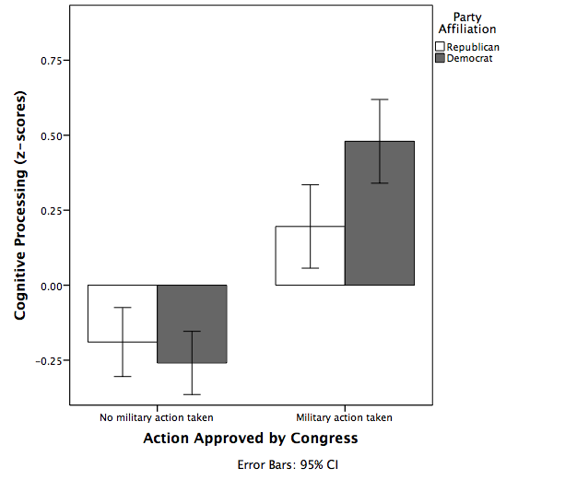

*Figure 1.* Interaction between party affiliation and action taken examining cognitive processing for hypothesis 1.